**Student Survey Questions for NetVUE Fostering Leadership in Communities of Faith Grant Participants**

*Instructions*

Please survey your students using the required questions provided below. Before surveying students, we encourage you to make sure the language in the questions will make sense to students. In particular, pay attention to the words in brackets. You may find that you need to make changes to those words so that students understand the questions.

You can choose to give your students only the required questions as a stand-alone survey, or you can include these questions alongside other questions you would like to use for your own purposes. At the bottom of this document are additional optional questions. These questions are available to use if you have not done other surveying of your students and would like to learn more, but are not required for NetVUE assessment purposes.

Once your students have completed the survey, you should submit their results through the assessment link provided to you by e-mail. The assessment will ask you to summarize what you learned through surveying the students. It will also ask about other aspects of progress and learning from your grant.

*Required Questions*  
Note: students should score their answers on a scale of 1-5 so that you can report the average score of their responses for each question when you submit your results. For example:

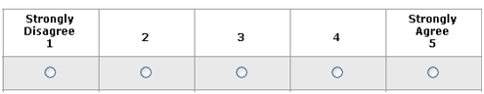

1. I feel more connected to the [community of faith] with which I am working than I did at the beginning of the program.
2. I have a better understanding of the work of a leader in the [community of faith] with which I am connected.
3. Participation in [Name of program or class] has helped me develop leadership skills that support my work in a [community of faith].
4. Through participation in [name of program/class], I developed a better sense of my vocation, calling, or purpose as it relates to leadership in a [community of faith].